**SQL Data Export and Import Wizard**

Use this wizard to either export or import SQL generated from MySQL Workbench or with the **mysqldump** command.

Access these wizards from either the Navigator area of the sidebar, or by selecting **Server** from the main menu, and then either **Data Import** or **Data Export**.

**Note**

This wizard only exports/imports the MySQL SQL format.

**Data Export**

This tab allows you to export your MySQL data. Select each schema you want to export, optionally choose specific schema objects/tables from each schema, and generate the export. Configuration options include exporting to a project folder or self-contained SQL file, optionally dump stored routines and events, or skip table data.

**Note**

Alternatively, use [Export a Result Set](https://dev.mysql.com/doc/workbench/en/wb-admin-export-import-results.html#wb-develop-sql-editor-export) to export a specific result set in the SQL editor to another format such as CSV, JSON, HTML, and XML.

Select the schema objects to export and then configure the related options. The figure that follows shows the sakila database ready for export.

**Note**

Click Refresh to load the current objects.

**Navigator Administration: Data Export: Object Selection**

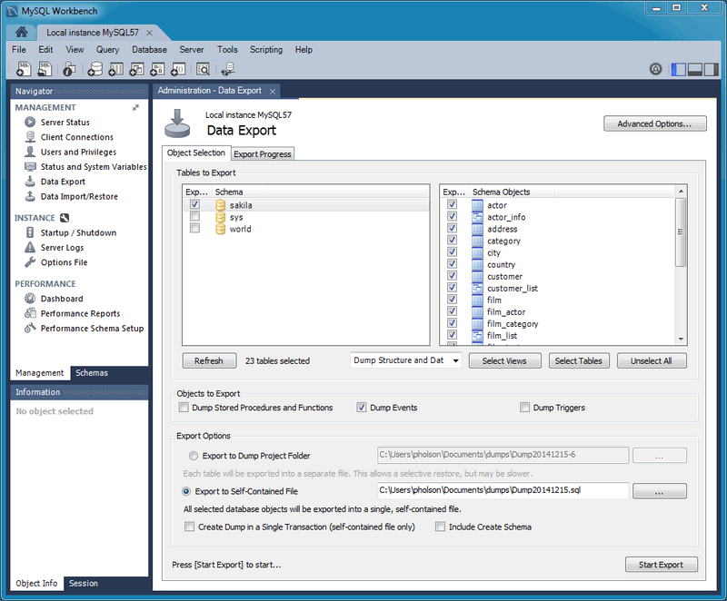

Optionally open the Advanced Options tab that allows you to refine the export operation. The next figure shows an example that adds table locks, uses replace instead of insert statements, quotes identifiers with backtick characters, and so on.

**Navigator Administration: Data Export: Advanced Options**

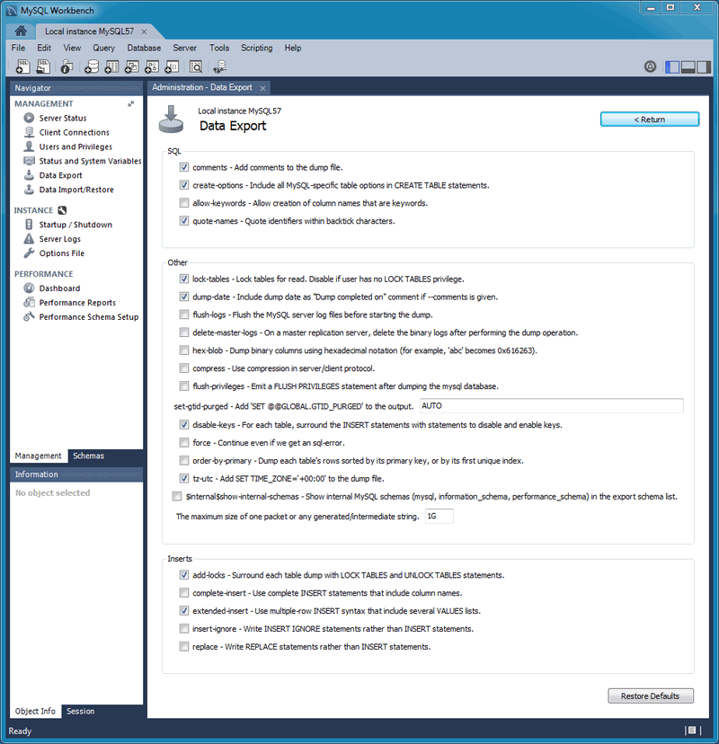

Click Start Export to begin the export process. As the next figure shows, status information indicates when the export is finished.

**Navigator Administration: Data Export: Export Progress**

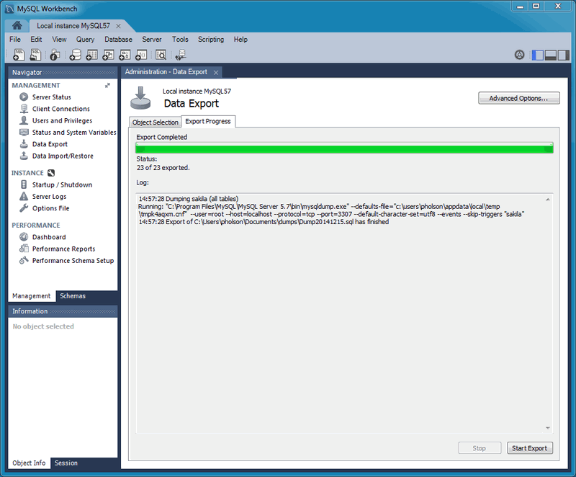

This functionality uses the **mysqldump** command.

**Data Import/Restore**

Restore exported data from the **Data Export** operation, or from other exported data from the **mysqldump** command.

Choose the project folder or self-contained SQL file, choose the schema that the data will be imported to, or choose New to define a new schema. The following figure shows an example of an import from a dump project folder.

**Navigator Administration: Data Import: Import From Disk**

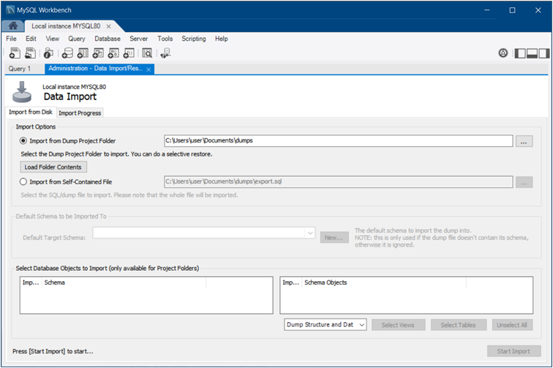

**Note**

You may only select specific data objects (tables) to import if the data export operation used project folders instead of a self-contained SQL file.

Click Start Import to begin the import process. Use the **Import Progress** tab to monitor the progress. Status information indicates when the import is finished and displays the log.